**THREE ADDRESS CODE FOR LOOPING ,CONDITIONS ,SWITCH CASE STATEMENTS USING INTERMEDIATE CODE**

Shanmukha Sudha Kiran.T-**211FA04003**, RaviKiran.K- **211FA04043**,

Deepthi .U -**211FA04046**, Sahil Raj - **211FA04677**

**BATCH-17,3Rd B. TECH, CSE BRANCH, VFSTR DEEMED TO BE UNIVERSITY**

**ABSTRACT:**

In this paper, we initiate our exploration by introducing the concept of Intermediate Code as a pivotal metric for deriving Three Address Code. The focus lies on generating intermediate code for looping and conditional statements, as well as switch-case structures. To exemplify the application of these concepts, we delve into the intermediate code generation for a switch-case scenario, using a simple calculator as an illustrative example. Through this exercise, our objective is to elucidate the intricate process of determining Three Address Code within the context of practical problem-solving.

**PROBLEM STATEMENT:**

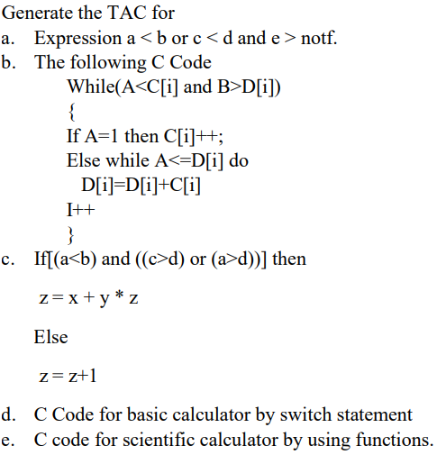

**INTRODUCTION:**

**INTERMEDIATE CODE:**

Intermediate code is a machine-independent representation used during compilation. It acts as a bridge between high-level source code and target machine code. This abstract representation simplifies program analysis and optimization. Examples include three-address code or abstract syntax trees.

Intermediate code can be represented in three ways :

1. Linear Representation
2. Hierarchical Representation
3. Three address code(TAC)

**THREE ADDRESS CODE:**

Three Address Code is a low-level intermediate code representation used in compilers to express instructions with at most three operands. Each instruction in this format typically contains an operation, along with two source operands and one destination operand. It simplifies the translation from high-level programming languages to machine code by providing a more manageable and uniform structure for compiler optimizations and code generation.

Three address code can be represented using:

1. Quadtriples
2. Triples
3. Indirect Triples

**ALGORITHM:**

1.start

2.Read two values a,b.

3.Read the operator ,which is used to perform operation.

4. Initialize a variable result to store the calculation result.

5.Maintain the function to calculate Intermediate code.

6.With in function apply basic calculation using operator.

7.For addition (operation == '+'):

* Call the add function with num1 and num2 as arguments.
* Store the returned value in result.

8.For subtraction (operation == '-'):

* Call the subtract function with num1 and num2 as arguments.
* Store the returned value in result.

9.For multiplication (operation == '*'):

* Call the multiply function with num1 and num2 as arguments.
* Store the returned value in result

10. For addition (operation == '/'):

* Call the division function with num1 and num2 as arguments.
* Store the returned value in result.

11.Convert each statement into Intermediate code.

12.Display the resulting code.

13.Stop

**SOURCE CODE:**

def generate_intermediate(cleaned_code):

final_code = []

current_temp = 1

for codeline in cleaned_code:

if '=' in codeline: # Assignment statement

variable, expression = map(str.strip, codeline.split("="))

temp_var = f"temp{current_temp}"

final_code.append(f"{temp_var} = {expression}")

final_code.append(f"{variable} = {temp_var}")

current_temp += 1

elif 'if' in codeline: # If statement

condition = codeline.split('if')[1].split('goto')[0].strip()

goto_line = codeline.split('goto')[1].strip('()')

final_code.append(f"if {condition} goto {goto_line}")

elif 'goto' in codeline: # Goto statement

goto_line = codeline.split('goto')[1].strip('()')

final_code.append(f"goto {goto_line}")

elif 'print' in codeline: # Print statement

value = codeline.split('print')[1].strip('()')

final_code.append(f"print({value})")

elif 'input' in codeline: # Input statement

variable, prompt = map(str.strip, codeline.split('='))

final_code.append(f"{variable} = input({prompt})")

elif 'return' in codeline: # Return statement

value = codeline.split('return')[1].strip()

final_code.append(f"return {value}")

elif 'END' in codeline: # End statement

final_code.append("END")

return final_code

# Example code

code = [

"def add(x, y):",

" return x + y",

"",

"def subtract(x, y):",

" return x - y",

"",

"def multiply(x, y):",

" return x * y",

"",

"def divide(x, y):",

" if y != 0:",

" return x / y",

" else:",

" return 'Error: Division by zero'",

"",

"# Input reading and function invocation",

"operation = input('Enter operation (+, -, *, /): ')",

"num1 = float(input('Enter first number: '))",

"num2 = float(input('Enter second number: '))",

"",

"result = 0",

"",

"if operation == '+':",

" result = add(num1, num2)",

"elif operation == '-':",

" result = subtract(num1, num2)",

"elif operation == '*':",

" result = multiply(num1, num2)",

"elif operation == '/':",

" result = divide(num1, num2)",

"else:",

" print('Invalid operation')",

"",

"# Output the result",

"print(f'Result: {result}')",

]

cleaned_code = [line.strip() for line in code]

final_code = generate_intermediate(cleaned_code)

print('\nIntermediate code is:')

for i, line in enumerate(final_code, 1):

print(f'{i}: {line}')

**OUTPUTS:**

**1)**

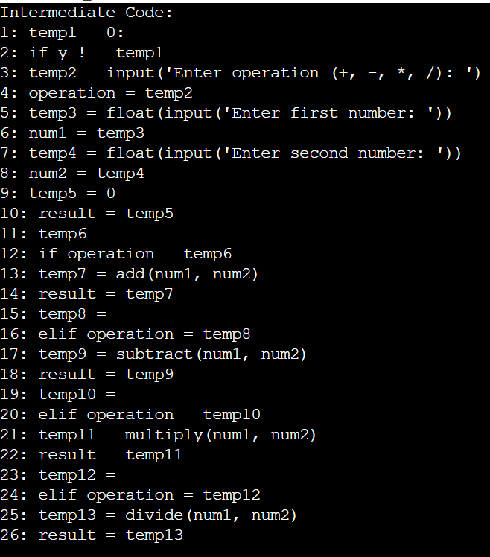

**2)**

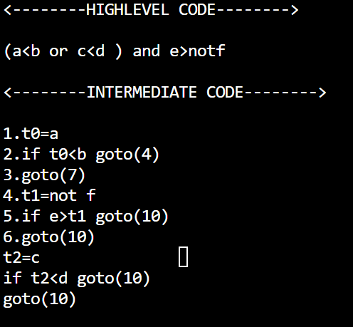

**3)**

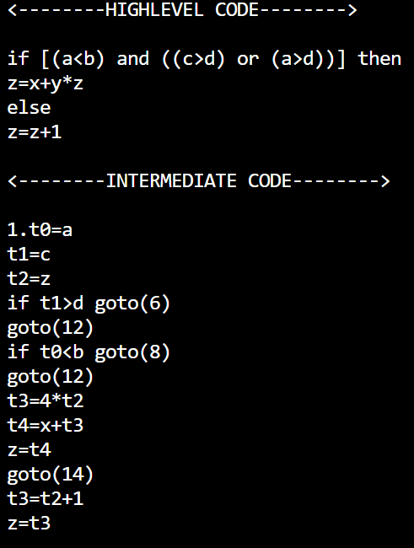

**NOTE:**

During the conversion of high-level code to intermediate code, it is essential to minimize the utilization of costly instructions while simultaneously optimizing the usage of memory space.

**REFERENCE:**

[**https://www.geeksforgeeks.org/intermediate-code-generation-in-compiler-design/**](https://www.geeksforgeeks.org/intermediate-code-generation-in-compiler-design/)

[**https://gateoverflow.in/174372/intermediate-code**](https://gateoverflow.in/174372/intermediate-code)

[**https://www.codingninjas.com/studio/library/intermediate-code-for-procedures**](https://www.codingninjas.com/studio/library/intermediate-code-for-procedures)

**CONCLUSION:**

In conclusion,The tasks provided cover various aspects of programming, including logical expressions, control flow structures, and Switch case .